food_item

**Note: the actual values (eggs, steak, etc.) listed in the tables are just examples to explain exactly what each attribute it.

|  |  |  |  |  |
| --- | --- | --- | --- | --- |
| food_name | serving_size | day_of_week | meal_type | dining_hall |
| Eggs | 1 | Monday, Tuesday | Breakfast, Lunch | Branford |
| Pulled Pork Sandwich | 4 oz. | Monday | Lunch | Stiles, Morse |
| Steak | 3 oz. | Friday | Dinner | Saybrook |
| Pizza | 6 oz. | Thursday | Lunch | Saybrook |

nutritional_information

This is the table that describes the nutritional information of each food item in the database. All the values are per single serving size, so I didn’t include that in the table.

**Note: the attributes in this table are listed in horizontal rows simply because there was not enough room to fit them all in vertical columns.

|  |  |
| --- | --- |
| food_name |  |
| calories |  |
| protein |  |
| fat |  |
| polyunsaturated_fat |  |
| saturated_fat |  |
| cholesterol |  |
| carbohydrates |  |
| sugar |  |
| dietary_fiber |  |
| calcium |  |
| iron |  |
| sodium |  |
| vitamin_C |  |
| vitamin_B1 |  |
| vitamin_B2 |  |
| riboflavin |  |
| niacin |  |
| vitamin_A |  |

ingredients

**This table describes whether or not a food has certain ingredients to allow students to personalize their eating choices in case they are allergic to certain things or have particular preferences. The responses will be ‘yes’ or ‘no’ for each food item. The attributes are also in horizontal rows because there were very many.

I chose these ingredients because the Yale dining specifies them on their website.

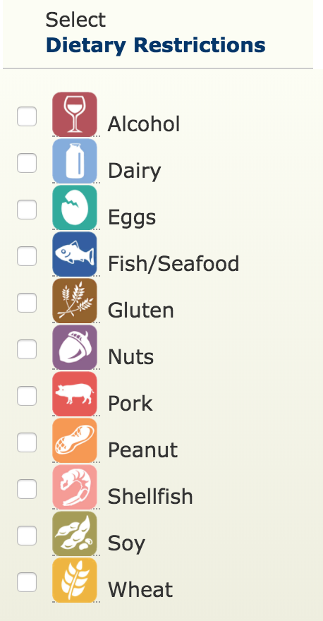

|  |  |
| --- | --- |
| food_name |  |
| alcohol |  |
| dairy |  |
| eggs |  |
| fish/seafood |  |
| gluten |  |
| nuts |  |
| pork |  |
| peanuts |  |
| shellfish |  |
| soy |  |
| wheat |  |

dietary_restrictions

**This table describes whether or not a food is vegetarian, vegan, or gluten_free so that the student can specify their preferences. The responses will be ‘yes’ or ‘no’ for each food item.

These dietary characteristics are highlighted on the Yale dining website.

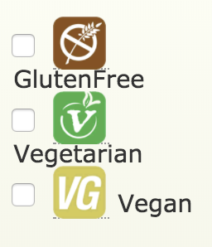

‘

|  |  |  |  |
| --- | --- | --- | --- |
| food_name | vegetarian | vegan | gluten_free |
|  |  |  |  |
|  |  |  |  |

recommended_macros

This is the table that describes the recommended dietary allowances and adequate intakes, total water, and macronutrients for people of a certain age and gender. Since the person to recommended macros relation is many to one (many people can have RDA’s but there is only one RDA per person=, the primary keys of person were used in the relation of recommended_macros.

The values are taken from the link in the proposal:

http://www.nationalacademies.org/hmd/~/media/Files/Activity%20Files/Nutrition/DRI-Tables/3_RDA%20AI%20AMDR%20Values_Total%20Water%20and%20Macronutr.pdf?la=en

**Note: the attributes in this table are listed in horizontal rows simply because there was not enough room to fit them all in vertical columns.

|  |  |
| --- | --- |
| age |  |
| gender |  |
| total_water |  |
| carbohydrate |  |
| total_fiber |  |
| fat |  |
| linoleic_acid |  |
| a-linoleic_acid |  |
| protein |  |

rec_daily_values

This is the table that describes the recommended daily intake of nutrients for adults and children 4 or more years of age based on a 2,000 calorie intake. These values do not depend on gender or age like the above ones.

The values will be taken from the link in the proposal:

https://www.dsld.nlm.nih.gov/dsld/dailyvalue.jsp

|  |  |  |
| --- | --- | --- |
| nutrient | unit_of_measure | daily_value |
|  |  |  |
|  |  |  |